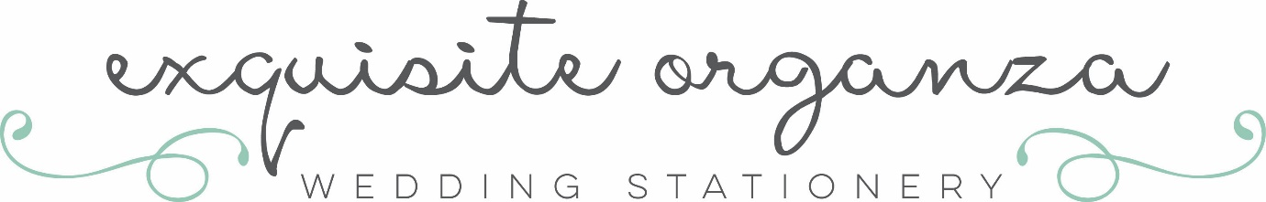
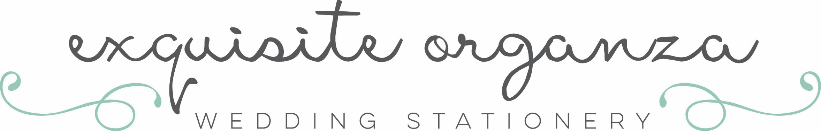

Poetry for that Special Someone
Please help with as much information as possible. All poems will be as personal to the recipient as possible, so please remember, I don’t know them but you do!
Answer the questions below in relationship to their relationship with you.
Only answer questions that are relevant and you would like something writing about.
I keep the Poetry as original as possible though there will be some words and phrases that are generic to this subject so may be used on more than one poem. If you order more than 1, I will endeavour to keep any repetition to an absolute minimum.
This is Bradley Hand Font—your poem will be written using this font.

The tone of the poem…. Funny/humorous,
thank you, romantic, cheeky
Why do you want this poem writing, why are they special to you
Their name
Male
Female
Age if a child
Relationship to you
Will they be at the wedding/occasion
Their Role e.g. Guest, Best Man etc.
How long have you been acquainted
Do they have a nickname
Do you have one they call you
Any other key people and relationship to subject……
…..Why do you want the above including…what happened
Any physical attributes you want mentioning
Occupation
Likes/dislikes
Favourite Places to visit……
…..Did they go with you?…what happened

Habits, good or bad
Favourite saying or use of words
Any More information (as much as possible please)

What they mean to you? Wedding?.....You’re moving on…will they? How do they make you laugh? Funny/sad/happy happenings, Anything from the your past together. When will you next see them…down the pub? At the christening?

Remember…. Please keep it relevant to your relationship with the person/wedding/event/occasion

Terms: Please return this form. I will forward a separate invoice for any poetry, which needs to be paid in full at time of ordering. Upon receipt of payment our contract will be in place and you will not be able to cancel. No refunds will be given. I will draught a poem and be in touch. There will be a maximum of 2 rough drafts per poem before the final draft is made. Please give me time to get my creative juices flowing…..sometimes more quickly than others, but always on time!

Thank you, Julie
Exquisite Organza Wedding Stationery
julie@exquisite-organza.co.uk

